_____________________________________________________________________________________
January 27, 2022
Product: Korogard® B300 Series Bumper Rails

Dear Korogard Wall Protection Systems Customer:
Koroseal Interior Products Certifies that Korogard B300 Series Bumper Rails:
- Contain 49% pre-consumer recycled content by weight per lineal foot
Korogard B300 Series Bumper Rails can contribute to a Building achieving the following points in the United States Green Building Council’s LEED® Rating Systems:
- Materials and Resources Credits: Recycled Content 4.1 & 4.2; Recycled Content
- Materials and Resources Credit; Building Product Disclosure and Optimization – Sourcing of Raw Materials (Recycled Content)

Please Contact your local Koroseal Sales Representative with any questions.
Regards,
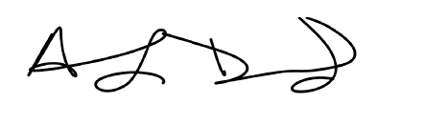
Anthony Drummond
Koroseal Interior Products

LEED® is a registered trademark of the United States Green Building Council
Korogard® is a registered trademark of Koroseal Interior Products

