_____________________________________________________________________________________
March 3, 2022
Product: Korogard® Protective Wallcovering

Dear Korogard Wall Protection Systems Customer:
Koroseal Interior Products Certifies that Korogard Protective Wallcovering:
- Are Greeguard® Certified for Children and Schools
- Final manufacturing location is Louisville Kentucky 40214
Korogard Protective Wallcovering can contribute to a Building achieving the following points in the United States Green Building Council’s LEED® Rating Systems:
- Indoor Environmental Quality; Low-Emitting Materials;LEED-Schools, LEED-Retai, LEED-Healthcare
- Material & Resources Credit 5 (Option 1); Regional Materials; LEED-CI (if building is within 500 miles of Louisville, Kentucky)
The XT-2000 Mastic adhesive, 3m Contact adhesive, and Spraylock Adhesive used to install Korogard Protective Wallcoverings:
- Contains less than 50 g/L of VOCs (complies with SCAQMD Rule # 1168); The mastic suppled by Koroseal contains 0 g/L of VOCs
The adhesive used to install Korogard Protective Wallcovering can contribute to a building achiving the following LEED points in the USGB LEED® rating systems:
- Indoor Environmental Quality 4.1; Low-Emitting Adhesives and Sealants; LEED-CI, LEED-NC
- Indoor Environmental Quality 4.1; Low-Emitting Materials; LEED-Schools, LEED-Retail, LEED-Healthcare
Please Contact your local Koroseal Sales Representative with any questions.
Regards,
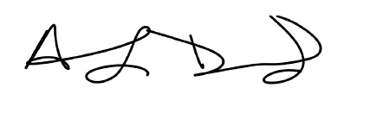
Anthony Drummond
Koroseal Interior Products
LEED® is a registered trademark of the United States Green Building Council
Korogard® is a registered trademark of Koroseal Interior Products

