_____________________________________________________________________________________
January 27, 2022
Product: Korogard® C460 Crash Rails

Dear Korogard Wall Protection Systems Customer:
Koroseal Interior Products Certifies that Korogard C460 Crash Rails:
- Contain 49% pre-consumer content by weight per lineal foot
- Final manufacturing location is Louisville Kentucky 40214
- Retainers can be reused by recovering with new profile covers
Korogard C400 Crash Rails can contribute to a Building achieving the following points in the United States Green Building Council’s LEED® Rating Systems:
- Material & Resources Credit 1.3; Building Reuse; LEED-NC, LEED-Schools, LEED-CI (1.2 and 1.3), (applicable for renovation projects)
- Material & Resources Credits 2.1 and 2.2; Construction Waste Management; LEED-NC, LEED-CI, LEED-School (applicable for renovation projects)
- Material & Resources Credit 4.1 and 4.2; Recycled Content; LEED-NC, LEED-CI, LEED-School
- Material & Resources Credit 5.1; Regional Materials; LEED-CI (if building is within 500 miles of Louisville, Kentucky)

Please Contact your local Koroseal Sales Representative with any questions.
Regards,
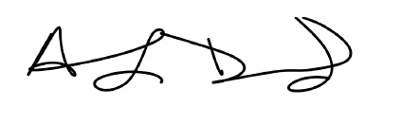
Anthony Drummond
Koroseal Interior Products
LEED® is a registered trademark of the United States Green Building Council
Korogard® is a registered trademark of Koroseal Interior Products

