_____________________________________________________________________________________
January 27, 2022
Product: Korogard® BW80 Chair Rails
Dear Korogard Wall Protection Systems Customer:
Koroseal Interior Products Certifies that Korogard BW80 Chair Rails:
- Contain 20% pre-consumer content by weight per lineal foot
- Final manufacturing location is Louisville Kentucky 40214
- Korowood™ Chair Rails can be reused by recovering with new profile covers
- Materials can be supplied with FSC Certified Wood
Korogard BW80 Chair Rails can contribute to a Building achieving the following points in the United States Green Building Council’s LEED® Rating Systems:
- Material & Resources Credit 1.3; Building Reuse; LEED-NC, LEED-Schools, LEED-CI (1.2 and 1.3), (applicable for renovation projects)
- Materials & Resources Credit 2.1 and 2.2; Construction Waste Management; LEED-ND, LEED-CI, LEED-schools (applicable for renovation projects)
- Material & Resources Credit 4.1 and 4.2; Recycled Content; LEED-NC, LEED-CI, LEED-School
- Material & Resources Credit 5.1; Regional Materials; LEED-CI (if building is within 500 miles of Louisville, Kentucky)
- Material & Resources Credit 7; Forest Stewardship Council Certified Wood; LEED-NC, LEED-CI, LEED-Schools
Please Contact your local Koroseal Sales Representative with any questions.
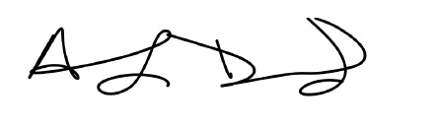
Regards,

Anthony Drummond
Koroseal Interior Products

LEED® is a registered trademark of the United States Green Building Council
Korogard® is a registered trademark of Koroseal Interior Products

