_____________________________________________________________________________________
January 27, 2022
Product: Korogard® BW70 Chair Rails

Dear Korogard Wall Protection Systems Customer:
Koroseal Interior Products Certifies that Korogard BW70 Chair Rails:
- Contain 18% pre-consumer content by weight per lineal foot
- Final manufacturing location is Louisville Kentucky 40214
- Materials can be supplied with FSC Certified Wood
Korogard BW70 Chair Rails can contribute to a Building achieving the following points in the United States Green Building Council’s LEED® Rating Systems:
- Material & Resources Credit 4.1 and 4.2; Recycled Content; LEED-NC, LEED-CI, LEED-School
- Material & Resources Credit 5.1; Regional Materials; LEED-CI (if building is within 500 miles of Louisville, Kentucky)
- Material & Resources Credit 7; Forest Stewardship Council Certified Wood; LEED-NC, LEED-CI, LEED-Schools
Please Contact your local Koroseal Sales Representative with any questions.
Regards,
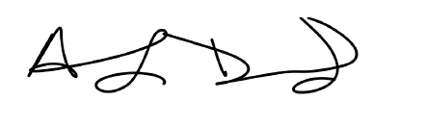
Anthony Drummond
Koroseal Interior Products

LEED® is a registered trademark of the United States Green Building Council
Korogard® is a registered trademark of Koroseal Interior Products

